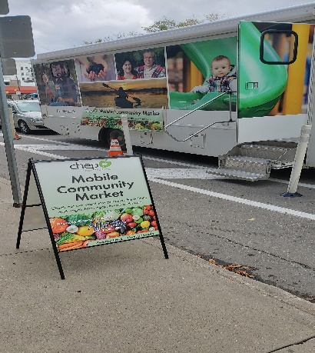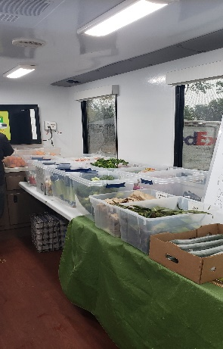
CHEP Good Food Mobile Market Pilot Project
September – October 2019

With financial support from the College of Medicine’s Division of Social Accountability Community Reciprocity Fund and Affinity Credit Union, along with use of the Saskatchewan Cancer Agency Bus, the Child Hunger Education Program (CHEP) ran a Mobile Market Pilot Project during September and October 2019. The mobile market took to the road every Tuesday and stopped at four locations – 21st Street in front of the downtown Public Library; Sutherland near St. Paul’s United Church; King George at 11th street and avenue L; and 1201 Broadway in Nutana near Augustana Church. In total, the mobile market reached 107 clients.

In running its markets, CHEP focuses on ‘food desert’ areas of Saskatoon (no ready access to fresh fruits and vegetables) and bulk purchases fresh produce at a wholesale price, passing this saving on to its customers. As a result of the project, Augustana church has requested to run its own fresh food community market whereby CHEP will bulk purchase and deliver the fresh produce and train volunteers provided by the church to manage the market.

Over the winter CHEP will focus on pop-up and community fresh food markets around Saskatoon and encourage various sites like churches and educational institutions in food desert neighbourhoods of Saskatoon to establish and manage their own community markets, with CHEP’s training and support.

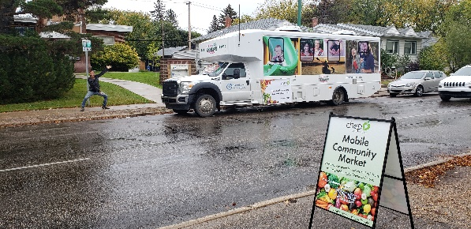

For more information about CHEP Good Food check out their website: https://www.chep.org/

